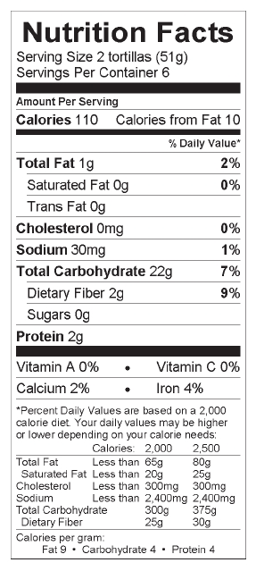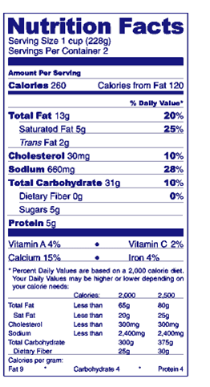

**Goals:**

30-45gm carbohydrates *per meal*

15-30gm carbohydrates *per snack*

Always have a healthy fat and protein with each meal and snack to prevent your blood sugar from spiking high very quickly.

Stick to healthy carbohydrates like fruits, vegetables and grains.

Stay away from sugary foods or drinks (pop, candy, desserts, etc)

Don’t skip breakfast!

Drink lots of water

Write down what you ate and drank on your blood sugar log if your blood sugar is 120 or greater after your meal.

Exercise after eating, even if it’s walking for 10 to 15 minutes

**Steps in Carbohydrate Counting**

1. You must count total carbohydrates of everything you eat *AND* drink for that snack or meal.
2. Count the carbs:
3. Determine the serving size (2 tortillas)
4. Determine the total carbohydrates in each serving size (22gm)
5. Plug in values:

# of servings x total carbohydrates per serving = grams you eat or drink of that item

1. Add up all grams of carbohydrates you are going to eat or drink.
2. Adjust your servings or omit something if you are going to have too many carbohydrates in that meal.

**Example:**

1 tortilla wrap with an egg: 0.5 servings x 22gm per serving = 11gm carbs

2 cups of yogurt: 2 servings x 31gm per serving = 62gm carbs

½ cup Milk (1 serving = 1 cup = 12gm carbs) 0.5 servings x 12gm per serving = 6gm carbs

TOTAL: 11gm + 62gm + 6gm = 79gm carb = **TOO MANY CARBS!**

**Let’s rethink our servings (or our food choices):**

1 eggs tortilla wrap 0.5 servings x 22gm per serving = 11gm carbs

1 cups of yogurt 1 servings x 31gm per serving = 31gm carbs

½ cup Milk (1 serving = 1 cup = 12gm carbs) 0.5 servings x 12gm per serving = 6gm carbs

TOTAL: 11gm + 31gm + 6gm = 48gm carb= **YES! (And you have healthy fat and protein in the milk, yogurt, and egg)**